Examples and Intuitions I

A simple example of applying neural networks is by predicting x_1*x*1​ AND x_2*x*2​, which is the logical 'and' operator and is only true if both x_1*x*1​ and x_2*x*2​ are 1.

The graph of our functions will look like:

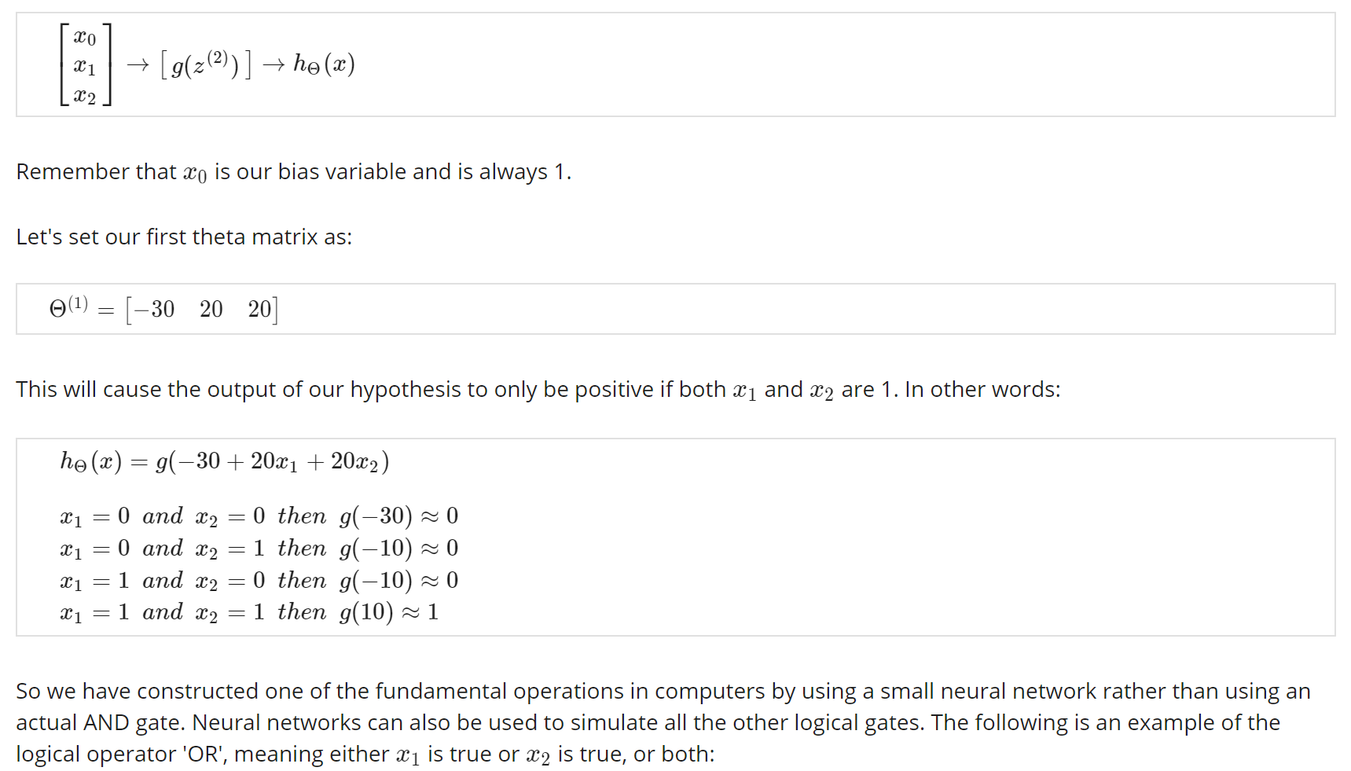

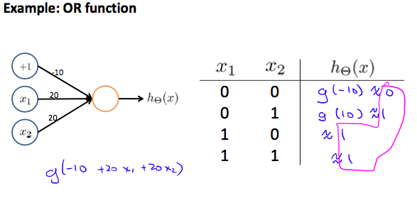

Where g(z) is the following:

